Project Heart: Game Design Document

# Classification

* Genre: narratively explorable escape room
* Platform: PC
* Target Group: Mature audience

# Story

Diego’s heart is broken into pieces after breaking up with their abusive partner, Taylor. The three pieces of his heart are now governed by three negative emotions. Anxiety is now tasked to deal with this situation.

This game deals with Diego having to do a big decision, you as the player control whether you heal or destroy his heart. As the player you get an insight into how his last relationship was through the flavor text of the items in the escape rooms. How the relationship works and game looks will shift gradually over time, in the same way that a good relationship gradually turns abusive so does our game; we also want to convey this feeling towards the relationship by keeping the abusiveness of the partner a secret until midway through the game.

# Gameplay

To progress in the game, you need to escape from several rooms within the heart. You may choose to solve the puzzles in each room and comfort each of the emotions with the help of narrative clues in the environment. However, you may also choose to destroy the puzzles and murder these negative emotions.

Every level you can speak with the emotion of said level. This will give the player insight into what Diego is feeling while also giving a sort of quest. These quests will ask you to prove something to them with an item, this item is the last thing you unlock in the escape room, giving the player a reason behind their actions and moving the plot forwards.

# Story-Gameplay Balance or Level Structure

**Stairs:** One key aspect about our game is our usage of stairs to connect things. Stairs will be used to connect levels, visuals and story between each segment of our game.

When a player is walking on stairs after a while, they have the control of the character taken away from them, then a cinematic moment starts where the outside story is shared to the player while their character slowly approaches the next level. On these moments the player may have the ability to choose alternate story details that are actually unimportant, being able to do this may be cut due to time constraints

**Environment Order:**

-Cloud for ambience and as movement teaching moment

-Stairs for exposition

-First Level, Library. Game play and exposition

-Stairs

-Second Level, Greenhouse.

-Stairs

-Third Level, Void

-Ending sequence + Credits

# Unique Selling Point

The unique selling point of this game is that the player can consume the narrative in any way they choose. This way choice is not a game mechanic but rather a product of the player being free in this explorable environment.

# Characters

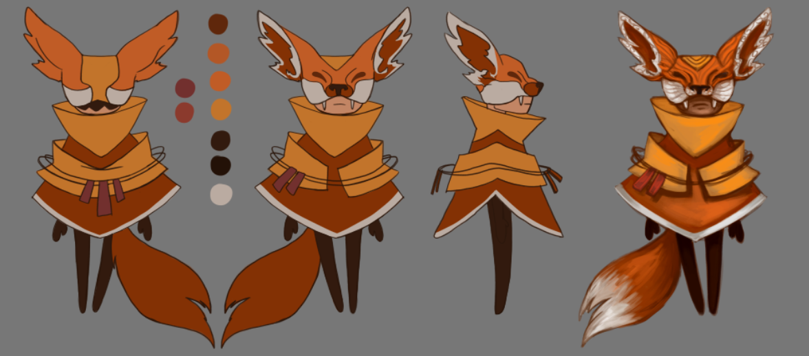

This is Anxiety, our player-controlled character. They are a nervous wreck that tries to keep its cool but fails more often than not.

Anxiety is a very two-sided character, while it tries to protect from harm it often ends up causing harm itself instead. This two-sidedness is just what we needed for our game in which you can heal or destroy the heart of Diego. The reason why we chose the fox to represent anxiety is because foxes are also seen as two-faced: as incredibly intelligent, yet also as traitorous.

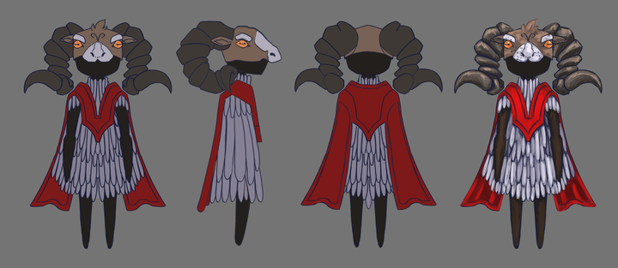

This is Anger, keeper of the library.

Fear, keeper of the Greenhouse; and Sadness, keeper of the void; will be developed later.

# Game Mechanics

**Narrative in items:** Most items in the game will have a narrative reason for being there and will contain information about the outside story that the player may or may not want to read. The goal is to reward the player for exploring the world, while also giving them the option to skip this if they’re not interested in this aspect of the game.

**Interaction item-environment:** Often to advance you to have to use an item on the environment. Like for example say you had the key and wanted to use it on a door. The way this works in game is first you have to the item selected from inventory (the selected item is shown constantly on the top left of the screen) and then click to interact on the desired environment object. Depending on our wishes the item may disappear from the inventory once used.

You may pick up items even though you have an item selected from your inventory.

If you try to interact with an environment that doesn’t react to your item (say for example you click on the door while holding a water bottle) the same message shows as it would if you had no item selected (here for example “This door is locked, I wonder where the key is”)

**Interaction item-item:** In your inventory you have the option to merge items together, creating a new one. An example for this would be to merge powdered milk with a glass of water to create a glass of milk.

**Knowledge Test:** The last challenge when finishing a level is a dialogue with the emotion of said level. Narratively the emotion is trying to get you to prove that you care about them by asking you questions about the outer story. As a mechanic what this does is test the player’s knowledge about the outside story, check if they have read the flavor text in the environment and items, and lastly end any misconceptions the player might have picked up about the outer story.

# Setting/Lore

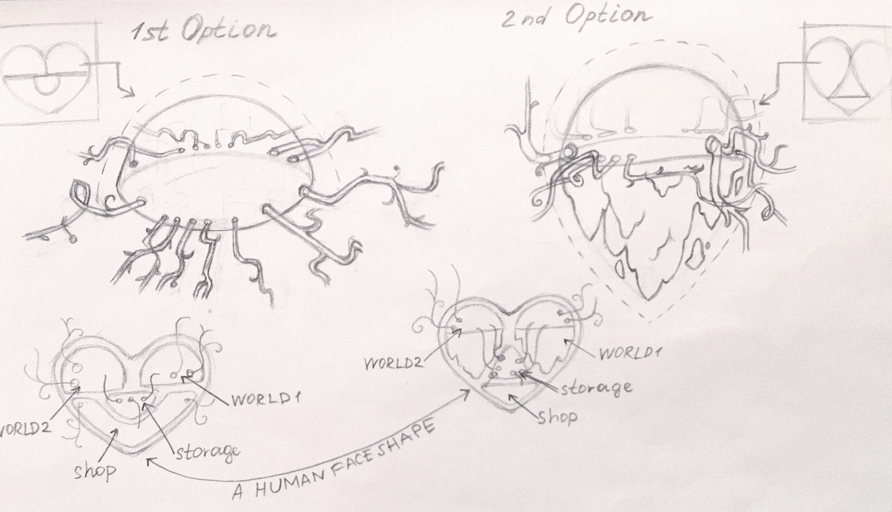

This game’s setting is the broken heart of Diego

# Level Art

## Library Level, Childhood Room

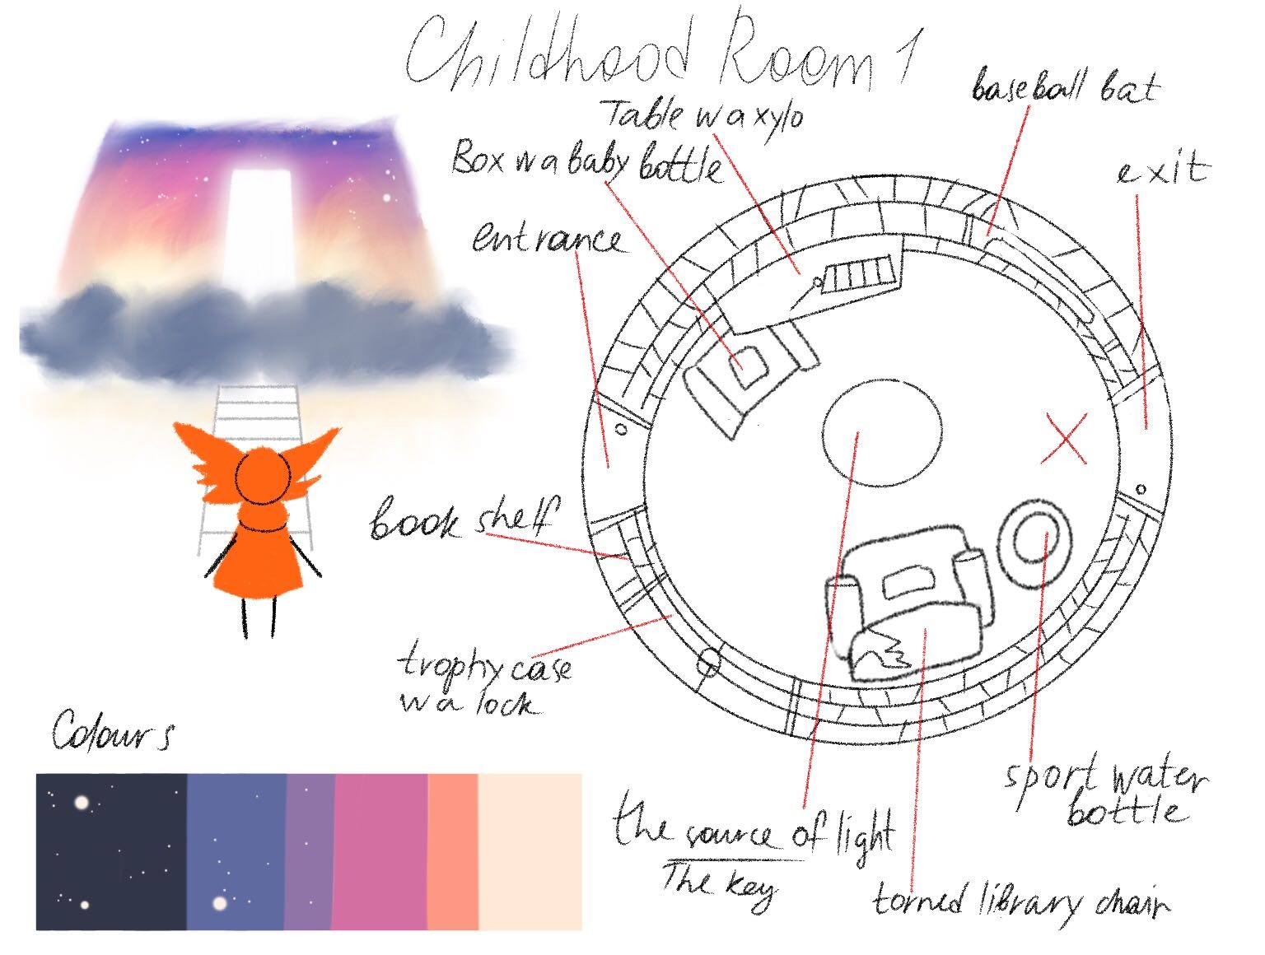

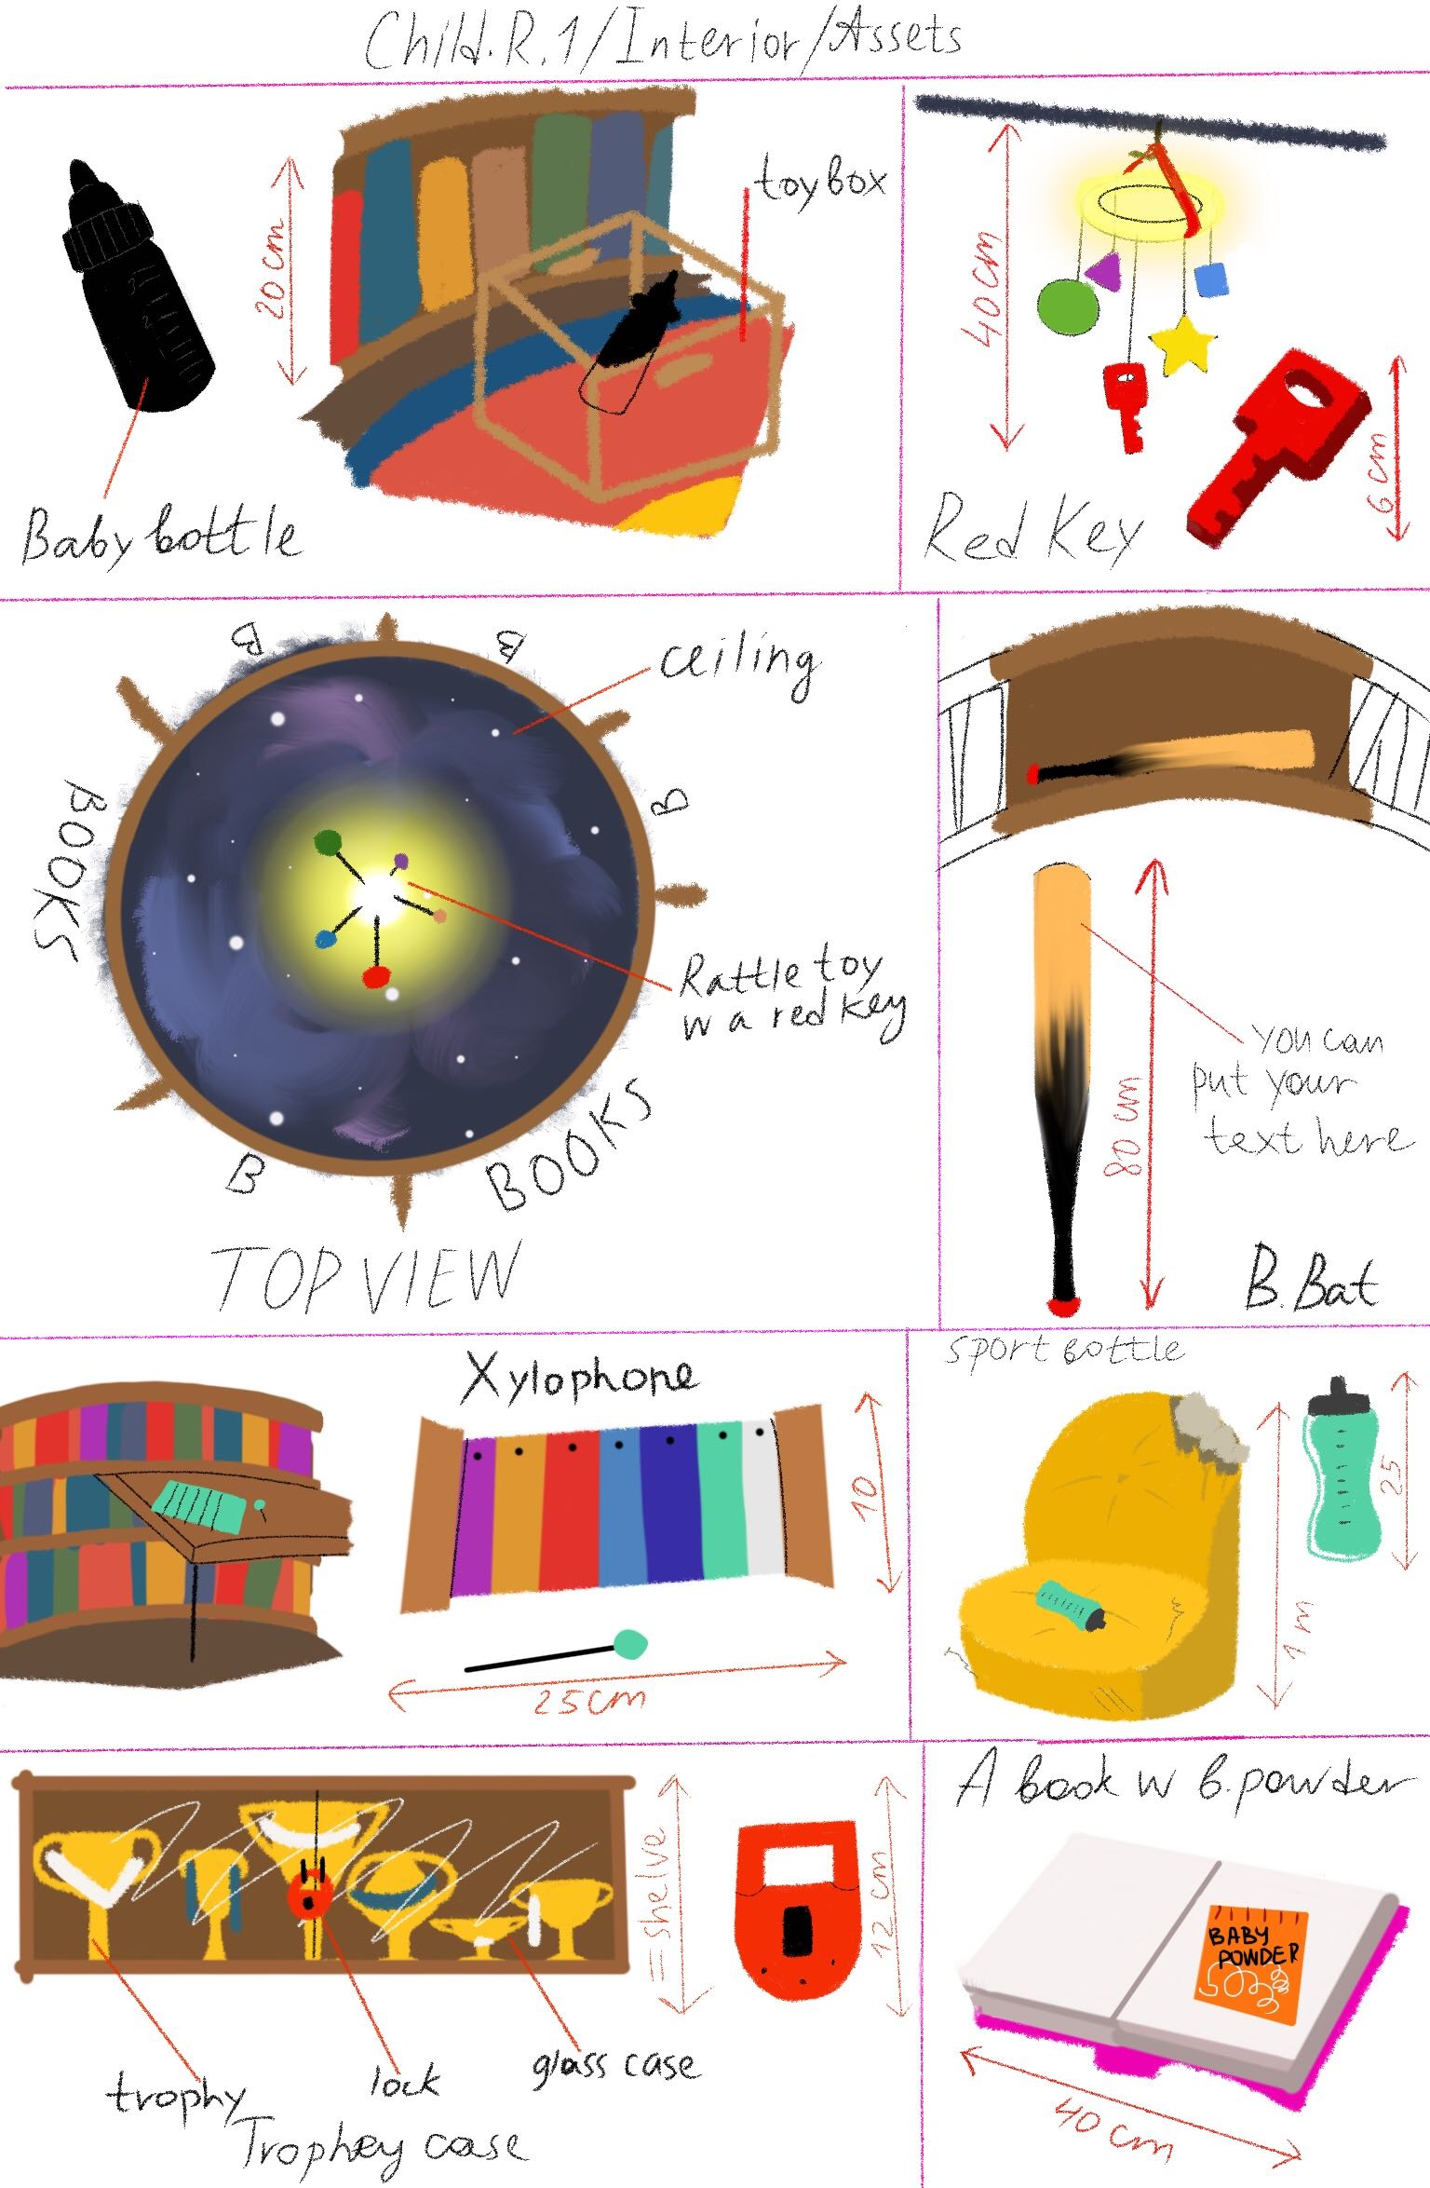

## Library Level, Letters Room

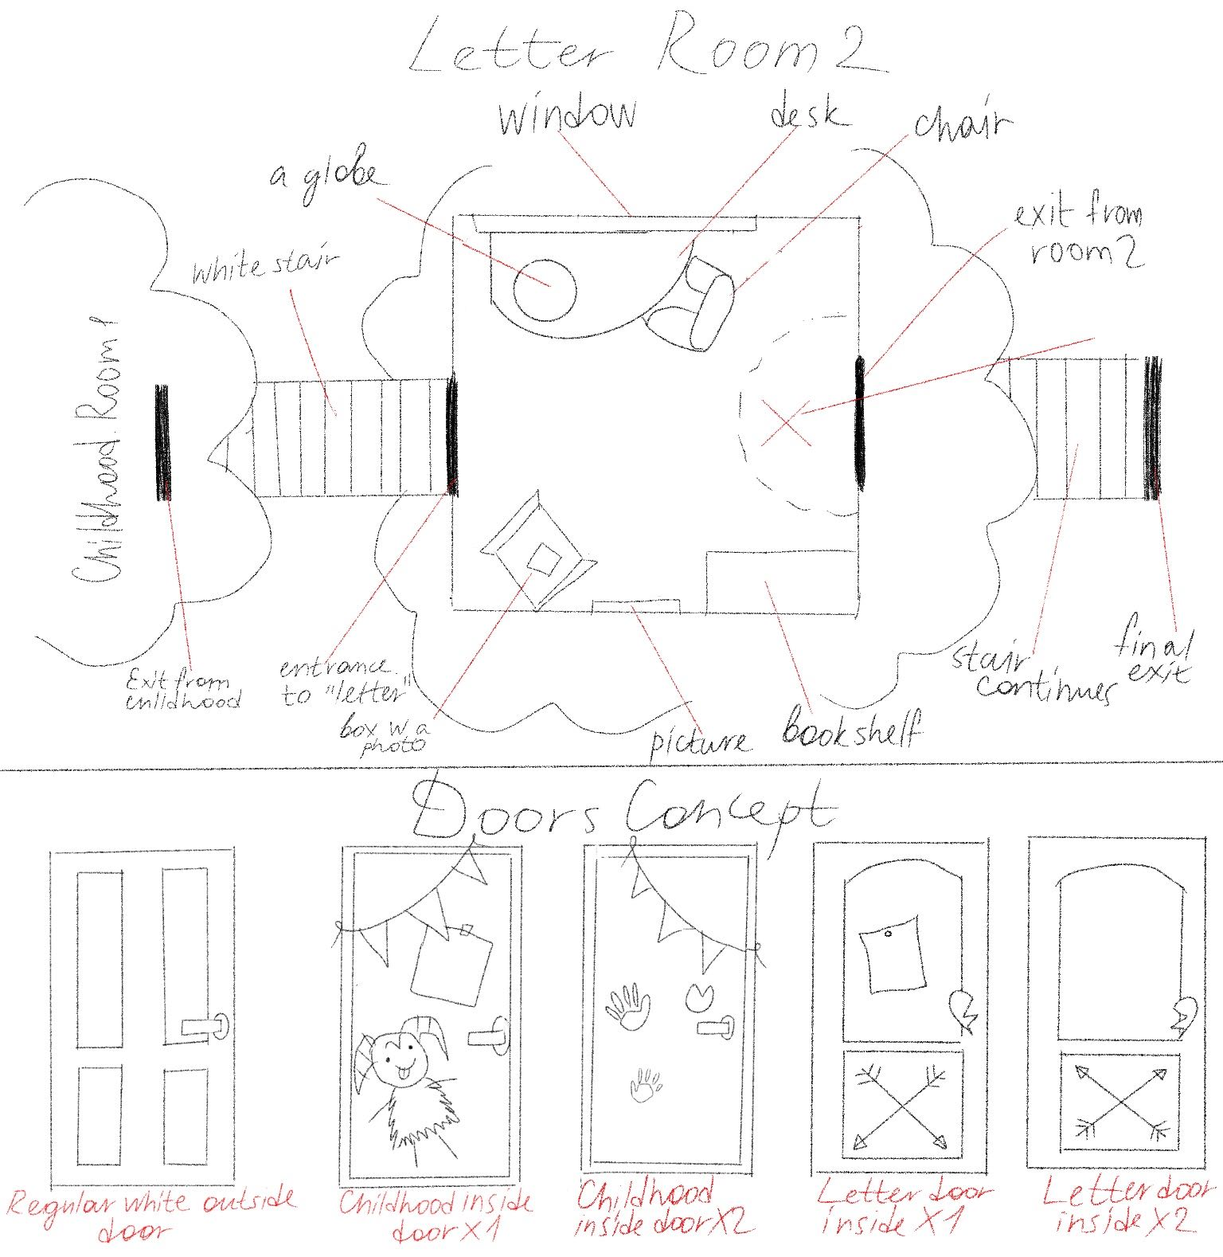

## Greenhouse Level Concept Art

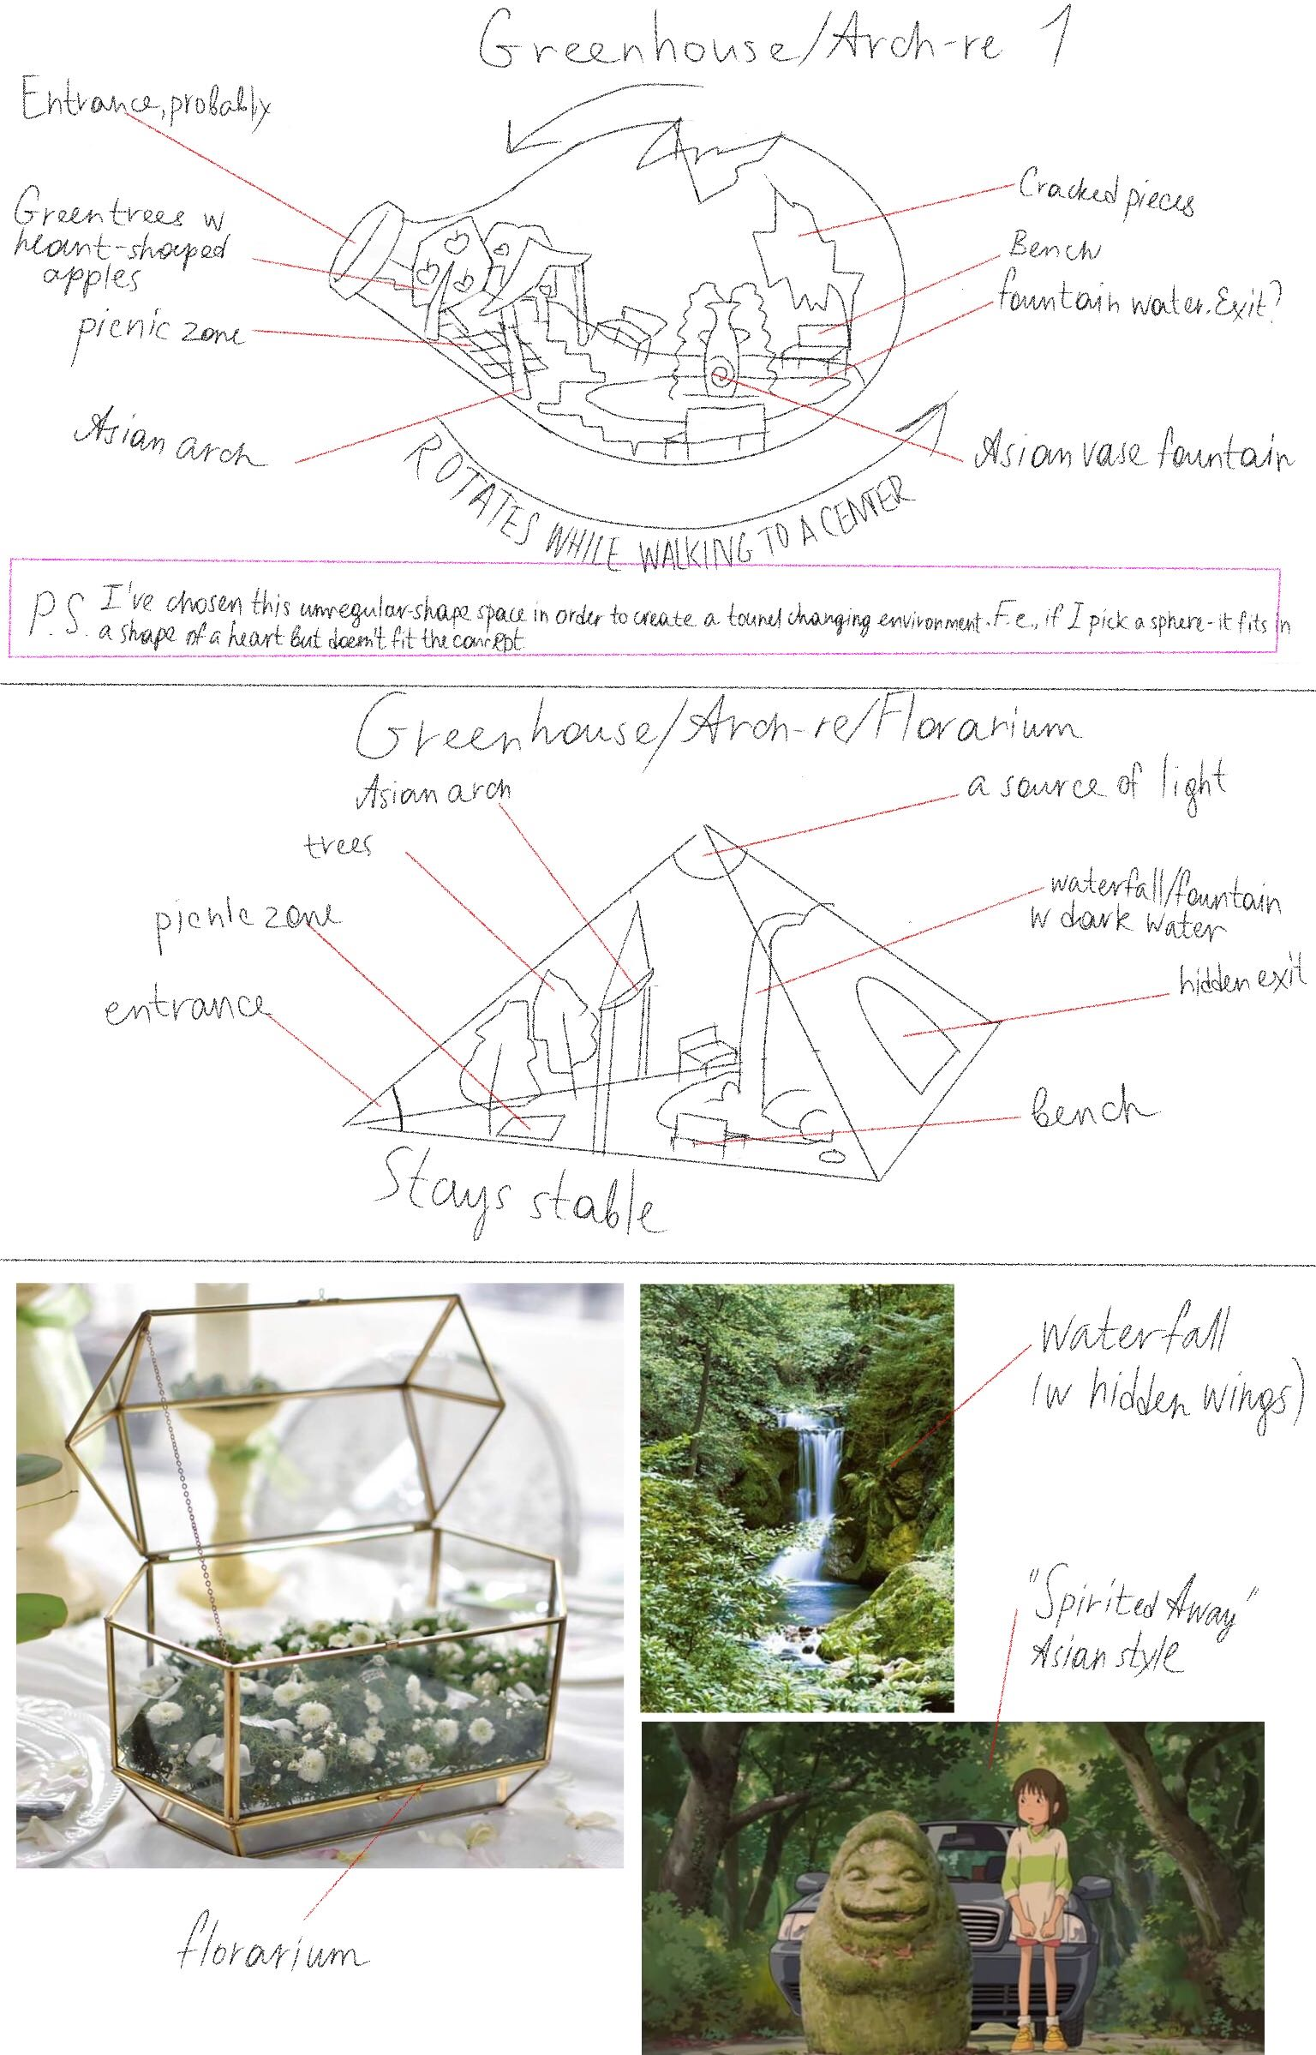

# Multiple Endings

This game features 3 endings that depend on the player’s actions in the game.

**Good Ending:** You solved all the puzzles without the use of weapons and comforted all the emotions. For this reason, Diego is now healed and able to love romantically again.

**Bad Ending:** To get this ending you have to kill all of the emotions.

**Neutral Ending:** To get this ending you have to either break a puzzle with the use of a weapon, murder less than 3 emotions, or fail too many times on the Knowledge Test of each level.

# Escape Rooms Cheat Sheet

(PU) means that an item can be picked up

# Library Level, Childhood Room

## Things available from the start

* Black Baby Bottle (PU)
* Rattle toy with Red Key (PU)
* Baseball bat (PU) (This is this level’s weapon)
* Xylophone with white keys

## How to solve the puzzle

After picking up the Red Key from the rattle toy, head to the Trophy Case with the big red keyhole and open it. Pick up the Sports Water Bottle inside.

The Xylophone has 8 white keys of receding size. The 8 trophies of receding size have white or red ribbons on them. Walk up to the Xylophone and touch the corresponding keys to turn them red. When done correctly you hear a clicking sound, and a book pops out of a shelf. This book contains Baby Formula (PU).

Combine the Black Baby Bottle, Sports Water Bottle and the Baby Formula. This reveals that the Black Baby Bottle had “paint gaps”; with the contrast of the white milk on the black bottle these gaps are now visible. The word “HELP” is now seeable in white on the bottle.

Type “HELP” into the door input to escape.

# Library Level, Letter Room

## Things available from the start

Taylor’s letter on top of the Desk with “PS: ILOVEYOU, TAYLOR” written in Tic-Tac code (PU)

## How to solve the puzzle

Notice Painting is crooked because of a dust mark on the wall. When you fix said Painting a Magazine will fall from behind it.

This magazine will enumerate 10 countries:

“1 – Germany; 2 – England; 3 – Canada; 4 – China; 5 – Australia; 6 – India; 7 – the US; 8 – Spain; 9 – Japan; 10 – Russia”

Look at the Globe/Map and write down the colored patterns of the previously mentioned countries, from doing this you should get:

“1 – Blue horizontal stripes; 2 – Green hearts; 3 – Brown; 4 – Purple stars; 5 – Yellow dots; 6 – Brown; 7 – Pink diagonal stripes; 8 – Orange squares, 9 – White triangles; 10 – Red zig zag”

This is the order in which you should put the color patterned books on the bookshelf first blue, red last.

By looking at the way the books are now arranged they make a code “17/07/2019” (this is because the brown books don’t have a number on their back)

Put this code into the locked cabinet of the desk. This will open it and give you a Tic-Tac code translation sheet (PU).

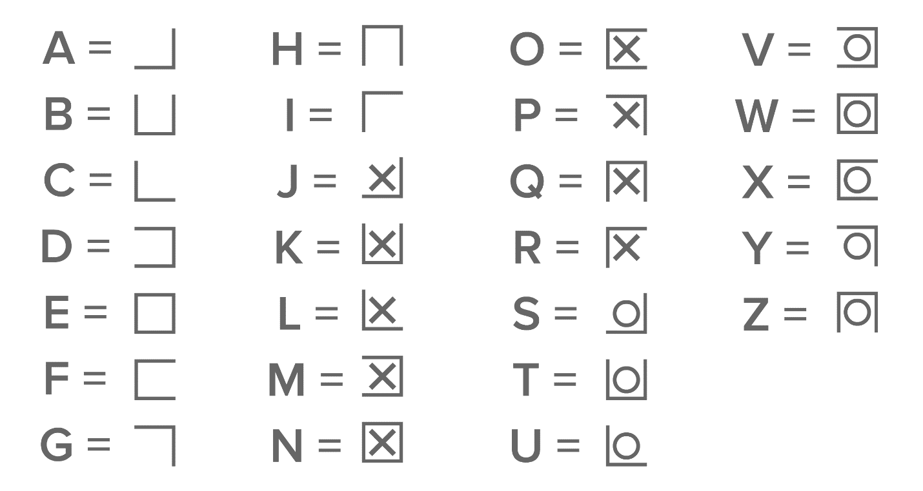

Use this code to Translate Taylor’s letter and then input the message in the box’s code field.

Opening the box gives you a Polaroid of Diego (the outer protagonist) and a kid in a nursery gown with “thank you” written on it.

With this the Room is solved! Present the photo to Anger to start the knowledge test.

# Greenhouse Level

A clear vase for flowers (it doesn’t have flowers inside of it) is fixed to the environment (can’t be picked up). Inside of it there is a Gashapon-looking capsule with a key inside. Since the opening of the vase is too small for the character’s hands, the player has to pick up a bottle of lemonade from a little picnic area and pour its contents into the vase.

The capsule floats due to the lemonade, so now it can be grabbed and opened to obtain a key.

This key is to be used on a heart shaped lock like the ones you see in bridges of tourist locations. This lock is on the picnic basket (located at the picnic area). Inside the basket there is a cellphone and a door handle.

This door handle is to be used on a toolshed. The door handle should have a (hexagonal) hole, and the door should have a little metal piece (that’s hexagon shaped) sticking out.

Inside the toolshed there is a radio. To proceed you have to input an AM frequency. The frequency needed is the same as the time on the big clock somewhere outside in the level (e.g. If it’s 9AM you input 9 Am as the frequency)

If the input is correct, you’ll hear 5 sounds (we need 3-5 different ones) These sounds are scattered on the level, near labeled objects (e.g. The waterfall produces one of these sounds and has a sign with a little icon next to it). You have to input these icons in order into a toolbox inside the shed.

Inside the toolbox there is a lever.

Put lever into electric box near Waterfall and pull to stop the waterfall, revealing a cave.

Inside the cave there is a Tv playing “Forget Me Not”. This has a games console attached to it, interacting with it will give you the game cartridge. Present this to Fear to start the knowledge test.

### Item List for Greenhouse

The greenhouse is *one main room* with a little *toolshed* (toolshed door has a hexagonally shaped metal piece where the handle should go) either inside or as a separate small room, behind the waterfall is a *cave*!

- Vase Statue (the vase is see-through), that is too heavy and big to move / pick up (the vase cannot be picked up). The vase opening can’t be much bigger than a hand, a hand is not supposed to fit through

-Gashapon-looking capsule that fits into the hole of the vase

- Key that fits into Capsule

- Picnic blanket

- Picnic basket

- Lemonade (Glass Jar)

-Love lock like the ones from tourist bridges or we can modify the heart lock to have a little shackle

- Cellphone – Screen has to be separate from rest of cellphone

-Door handle with hexagonal hole

-(Kitchen) Knife

- Radio

- Clock (showing a dial with AM & PM, this dial has to be legible to the player)

- 3 - 5 sounds, scattered across level, walking on grass, waterfall noise, +1 (artists can choose these freely as long as there is an according icon to it)

>> Little sign w icons for each sound

- Tool box w icons as the padlock (reuse lock from Level 1)

- Lever (stick)

- Electrical Box for the lever to go into (into the side probably), this turns the waterfall off

Cave with:

Game console w cartridge slit + cartridge (separate objects!)

Tv ((Forget Me Not Playing)), TV Screen : only ONE plain, not a cube!